

Save a copy of this document somewhere you can access.

This is ***your*** learning journal. Make sure that you keep it updated as you progress through the Project. Your teacher will let you know when to complete each step. Document both your successes and your failings as they provide the most important learning opportunities!

To get started, please type your name in the following box:

|  |
| --- |
|  |

# Step 1: Define

If instructed by your teacher, please answer the rest of the Define questions.

## Define the situation

By rewatching the situation video and/or doing your own research on the internet, try and answer the questions below. Your teacher will discuss the answers with you at the end, so don’t worry about getting them wrong. Write a one to two sentence answer in your learning journal under the Imagine section.

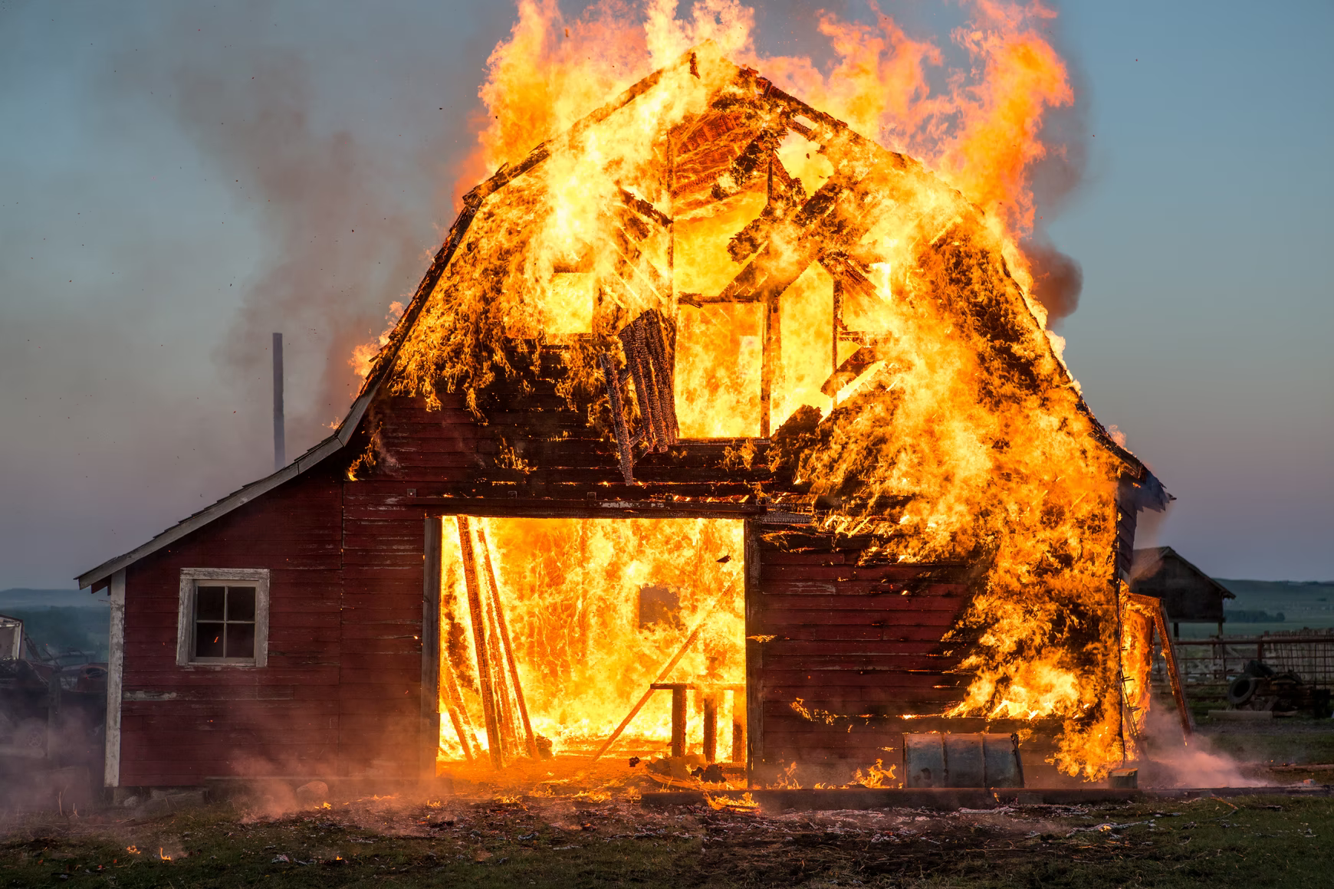 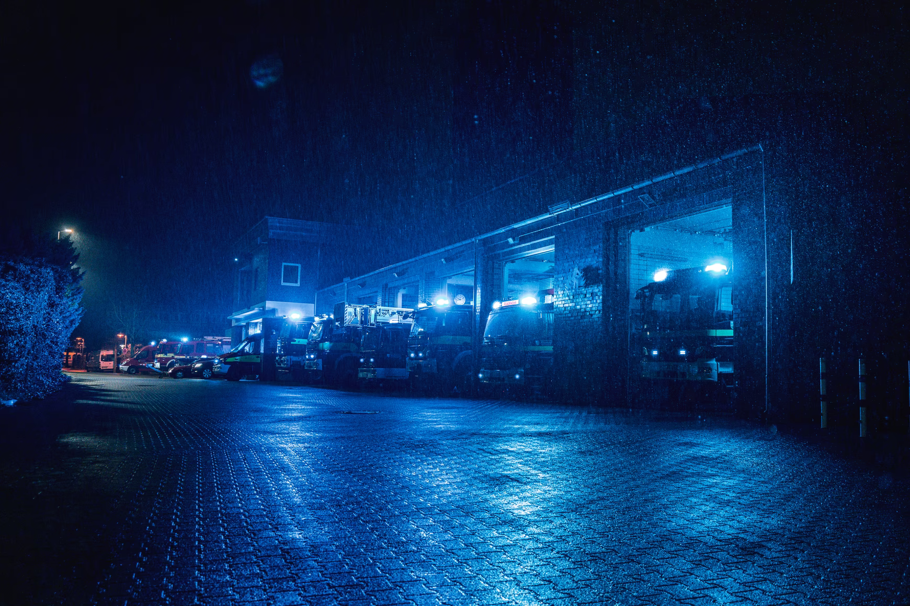

Our warehouse utilises line following robots to move the hydrogen fuel cells around.

1. What does “line following” mean?

|  |
| --- |
|  |

1. What are the advantages of using line following robots in a warehouse compared to human workers?

|  |
| --- |
|  |

1. Other than line following, how else could our worker robots navigate around a warehouse?

|  |
| --- |
|  |

We know from the situation that a fire is spreading throughout the warehouse!

1. What do you think could have been done to avoid the fire?

|  |
| --- |
|  |

1. What do most buildings have to detect fires?

|  |
| --- |
|  |

1. What do most buildings have to automatically put out a fire?

|  |
| --- |
|  |

We saw that there was an explosion when the firefighters tried to enter the warehouse.

1. Why did this explosion occur?

|  |
| --- |
|  |

1. How could this situation have been avoided?

|  |
| --- |
|  |

## Define the problem

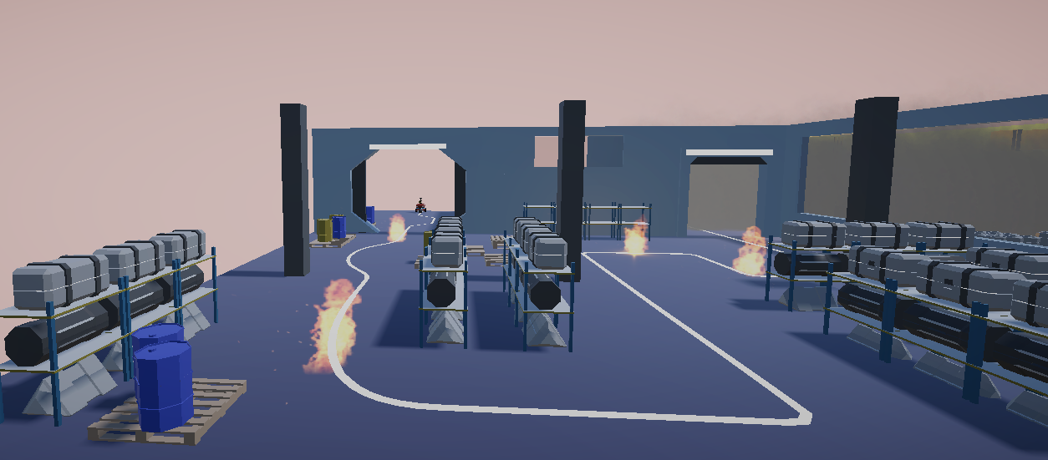

We don’t want to purposefully send human firefighters into highly dangerous situations (at least, more dangerous than normal fires).

1. What is the risk if we send human firefighters into the warehouse to try and put out the fire?

|  |
| --- |
|  |

1. Should we just leave the fire alone? Why or why not?

|  |
| --- |
|  |

1. State the problem that you need to solve.

|  |
| --- |
|  |

That's it so far for the learning journal! Return to the platform and move on to the next step: <https://app.createbase.co.nz/project/heat-seeker/imagine>. The platform will tell you when you need to return to the learning journal to answer more questions. Throughout the rest of the Project, always return to the platform after completing a step in your learning journal.

# Step 2: Imagine

Answer the following questions in Imagine before returning to the platform. If you are working in a group, discuss all of your answers as a team, but make sure that every member writes a summary in their own learning journal in the box below. Bullet points and incomplete sentences are acceptable.

## Imagine your solution

1. If we can’t send a *human* into the warehouse to put out the fire, and any existing automatic systems to put out the fire (like sprinklers) aren’t working, what could we send in to find and put out the fire instead?See how many creative solutions you can think of that don’t involve putting humans in harm’s way.

|  |
| --- |
|  |

1. If we want to replace a human firefighter with a robot/device, what functionalities is that device going to need to have? For example, one functionality is that it needs to be able to move from the warehouse entrance to the fire.

|  |
| --- |
|  |

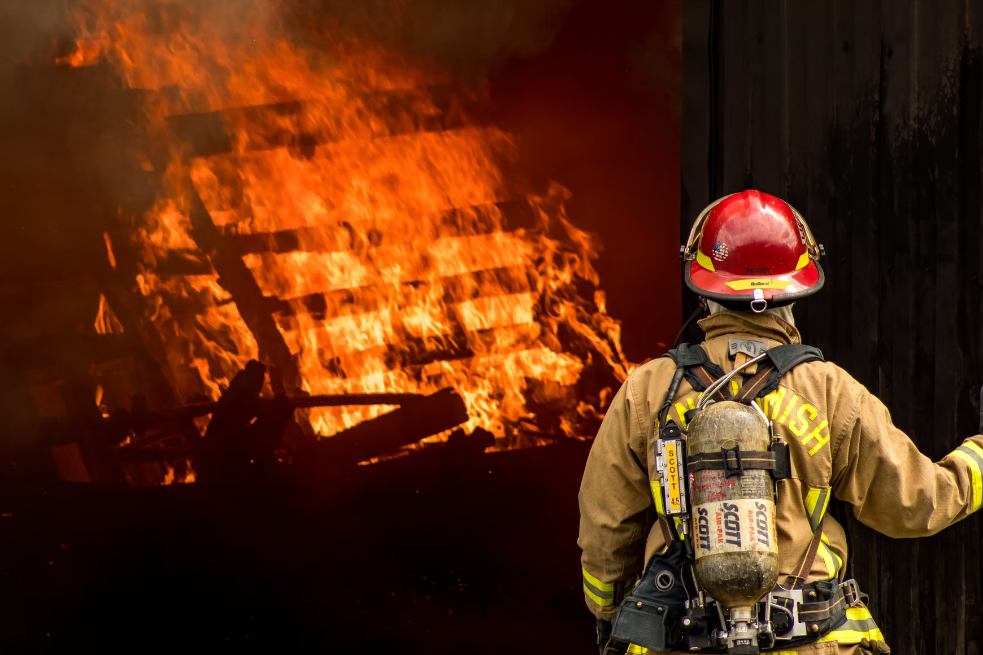 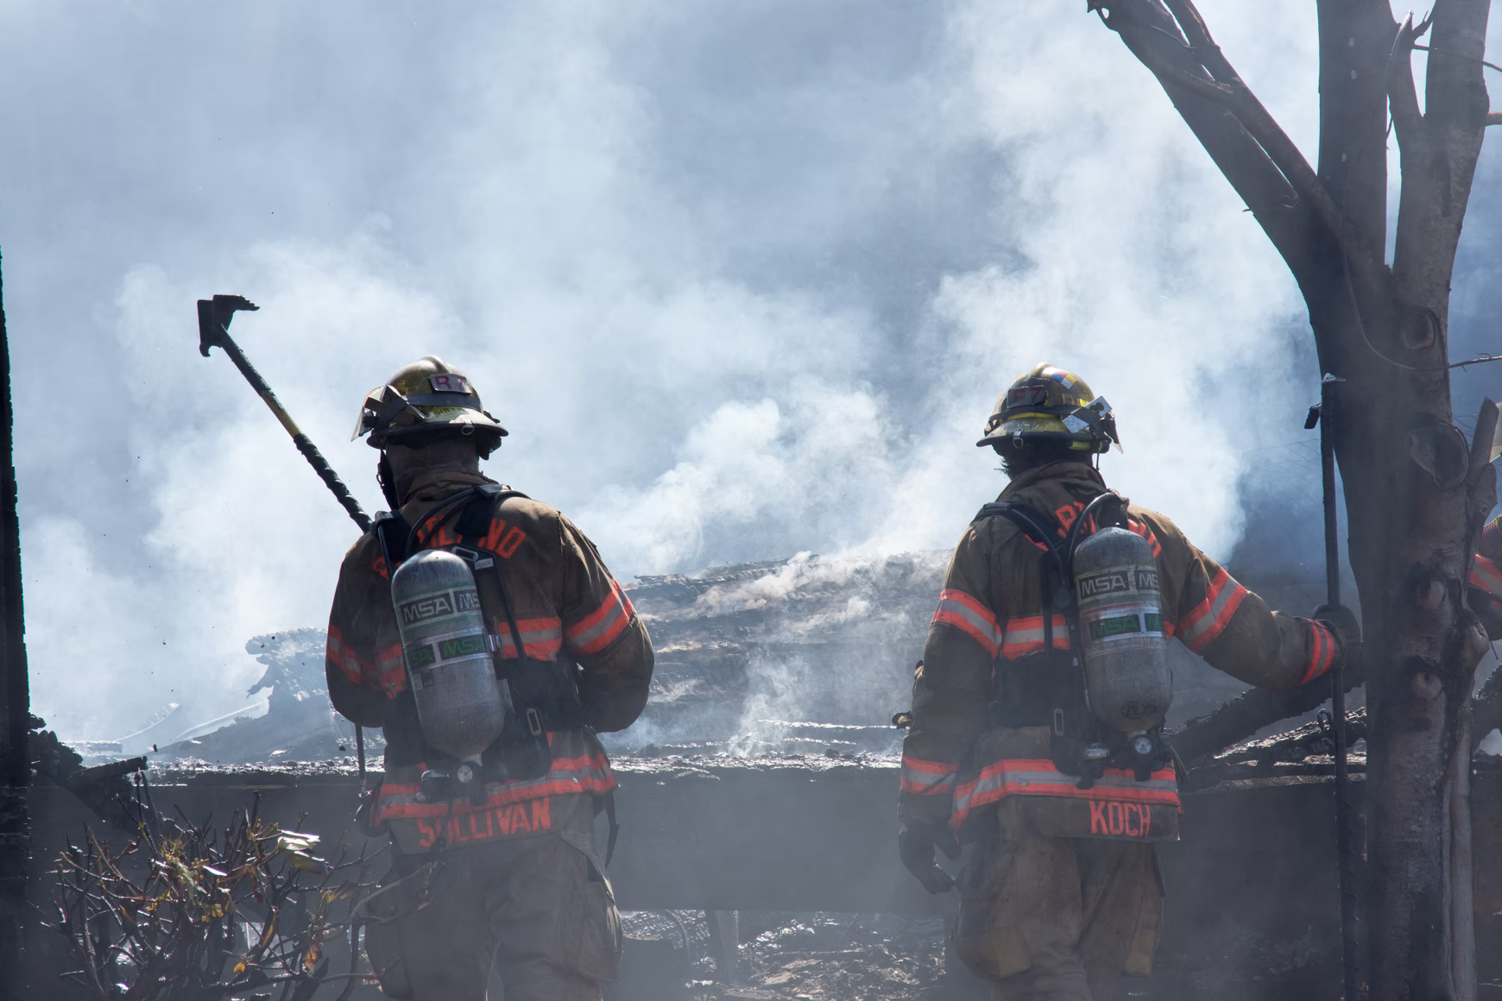

If we use a robot to solve this problem, we are going to need to program it to manually detect and put out any fires that it encounters on its journey. Luckily, every fire in our situation can be reached by following a line on the warehouse floor.

1. How could our robot navigate through the warehouse?

|  |
| --- |
|  |

1. How could our robot detect where each of the fires are?

|  |
| --- |
|  |

1. What should our robot do when it finds one of these fires?

|  |
| --- |
|  |

When you have finished answering these questions, return to the platform (<https://app.createbase.co.nz/project/heat-seeker/imagine>) and read all of the content in the three documents. It will include your next instructions!

# Step 3: Create

## Subsystem I: Speed control

### Research

A line following robot is one of many possible solutions that could be used to navigate its way through a warehouse to put out the fire. Answer the following questions about line-following robots in your learning journal. You may want to research your answers on the internet or discuss them with your classmates.

1. Describe what a line following robot is in one or two sentences.

|  |
| --- |
|  |

1. List two examples where a robot may use line-following for navigation.

|  |
| --- |
|  |

1. How does a line-following robot work?

|  |
| --- |
|  |

1. Discuss the importance of using lines for navigation for robots. Why do these robots use lines? What makes lines useful to them? Why would you use line following over other methods of navigation?

|  |
| --- |
|  |

1. What do you think would happen if suddenly there was no line? This may be the case if the lines are poorly maintained or incorrectly created.

|  |
| --- |
|  |

1. Can you find any real-life examples for the previous question?

|  |
| --- |
|  |

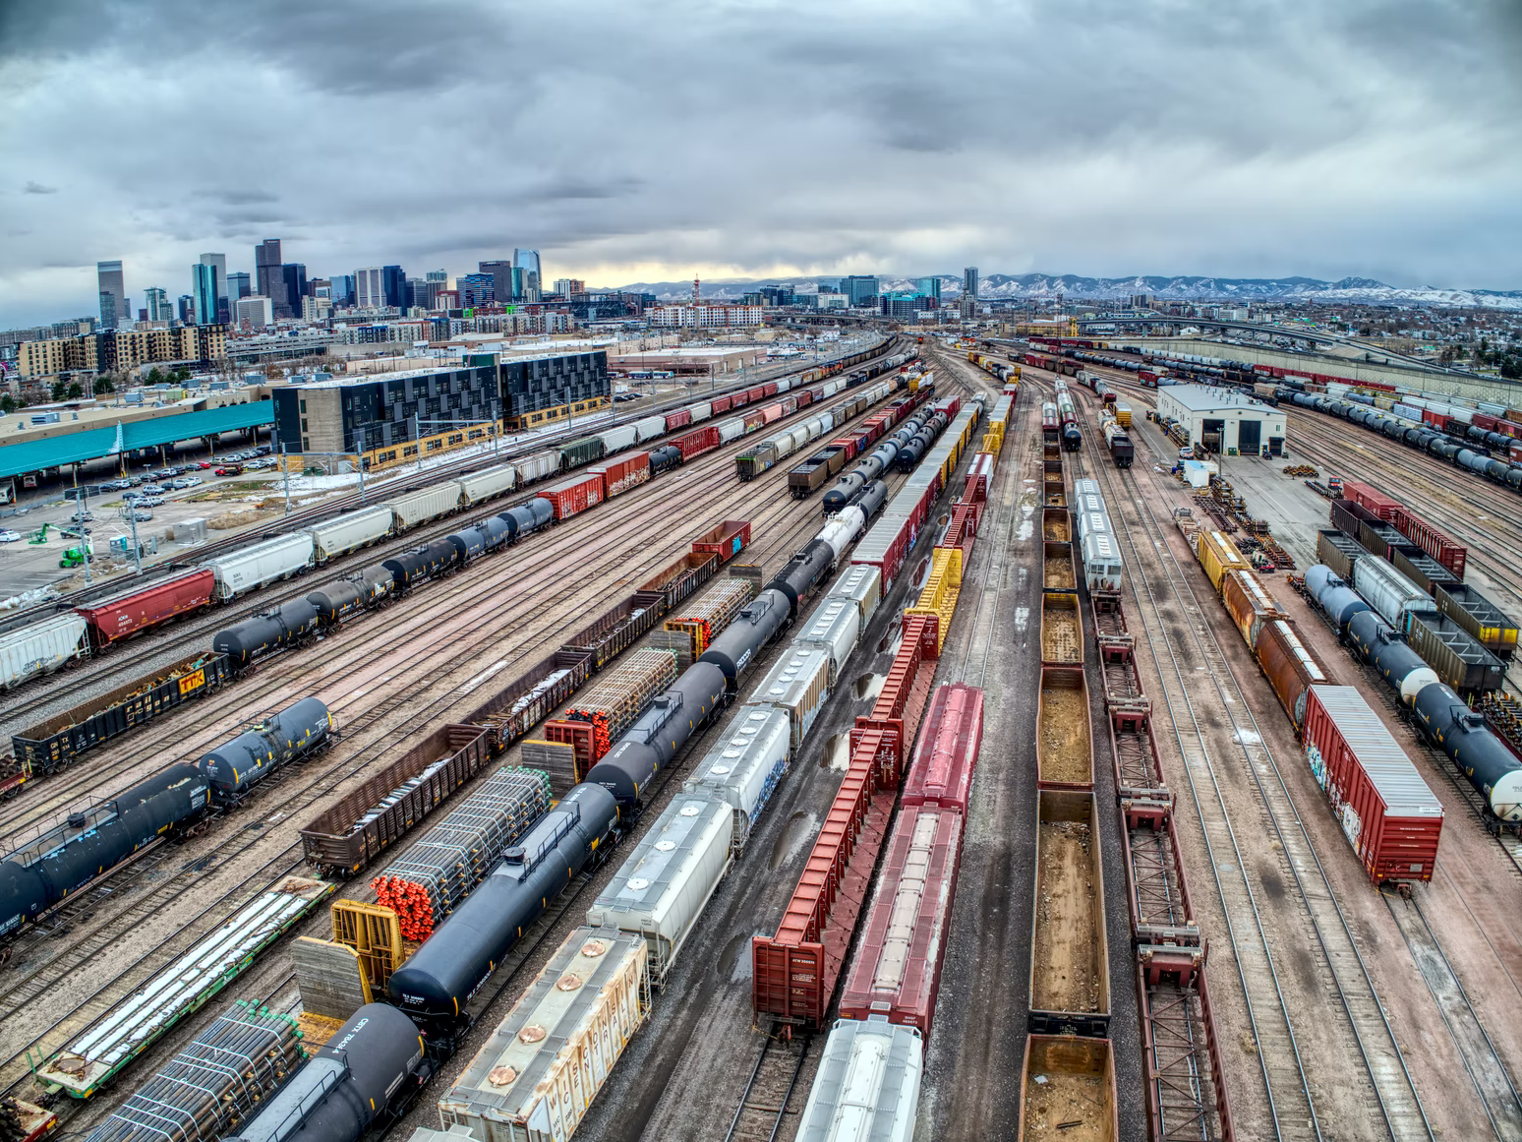 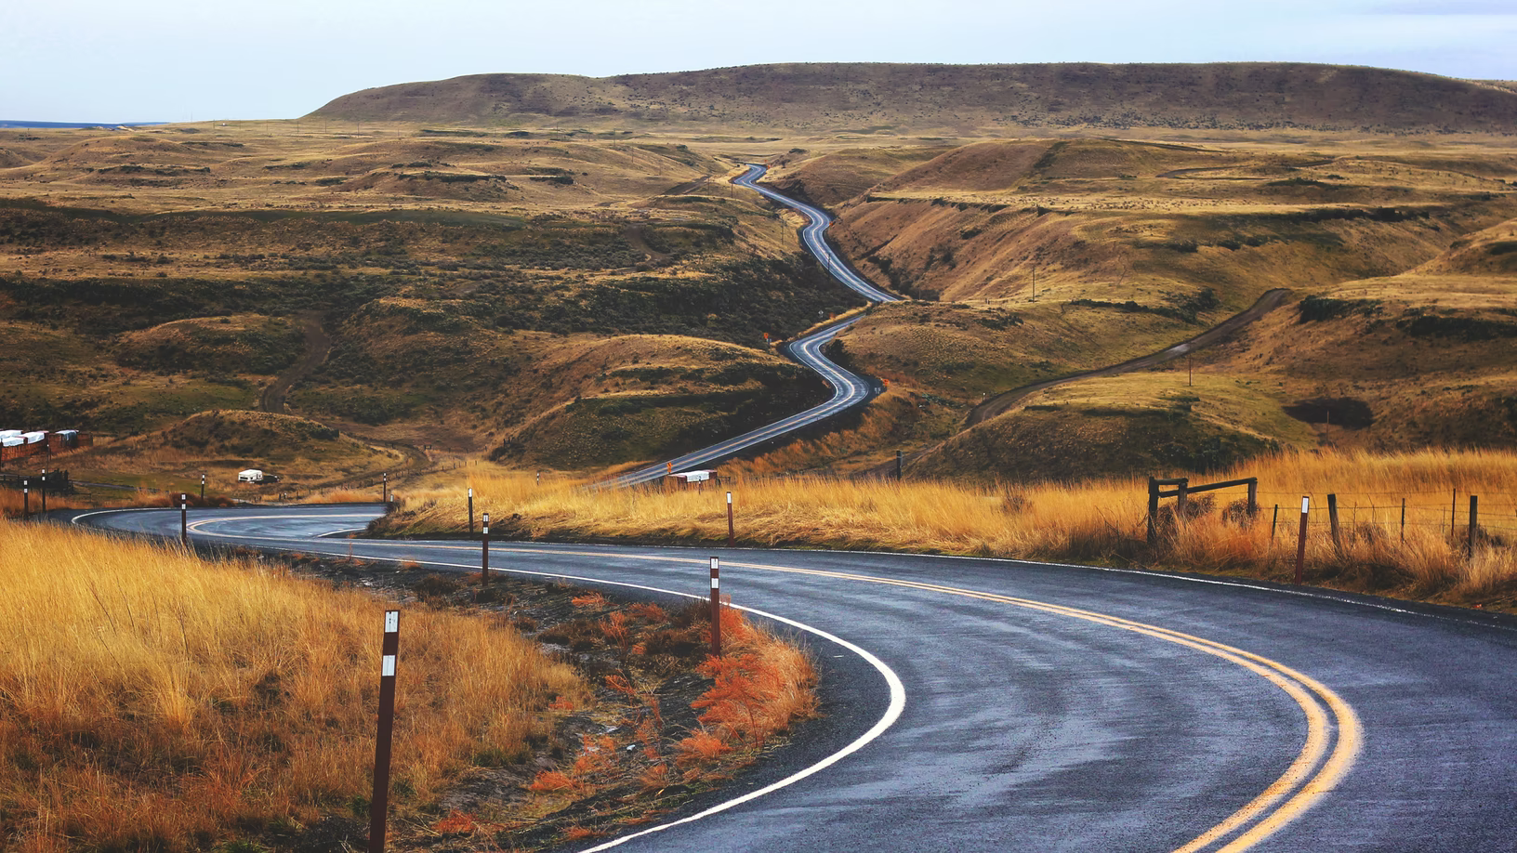

You have two programming options available to you for completing this Project. You can either code using a visual programming language called **Flow**, or a text programming language called **JavaScript** (JS). Your teacher will let you know what language they want you to use. Otherwise, feel free to choose. You can always switch between the two at any time.

If you are going to create your solution using **Flow**, then watch the Flow: UI tutorial video and read the Flow: Motor blocks document in the [Research](https://app.createbase.co.nz/project/heat-seeker/create/Speed%20control/research) step of the first subsystem. If you are going to create your solution using **JavaScript**, then read the Introduction to JS: Motor functions document in the [Research](https://app.createbase.co.nz/project/heat-seeker/create/Speed%20control/research) step of the first subsystem.

When you have watched/read the appropriate documents for the language you will be using, you will then be able to answer the following questions:

1. List the action blocks or functions that your robot will need to use to follow a line.

|  |
| --- |
|  |

1. For each of these blocks or functions, what action do they make our robot do? If the block or function has an input, how does this input change the resulting action?

|  |
| --- |
|  |

1. An actuator is a component of a machine that produces a linear or rotational motion, for example, a mechanical valve or an electrical motor. What actuators would our robot need to perform each of the actions above?

|  |
| --- |
|  |

### Plan

Within this step, our aim is to understand how we could move the robot through different paths by adjusting the speed of the wheels. To do this, let’s attempt to try and answer the following questions.

1. For each of the robot movements below, please indicate the speed that each of the robot’s individual motors should be set to in order to perform that movement. Getting the relative speed between each motor correct is more important than the magnitude of the speeds. For this exercise, you should stick to using the speeds -0.5 +0.25, +0.5, +0.75 and +1.
   1. Move Forward in a straight line:



|  |
| --- |
| Right Motor: |
| Left Motor: |

* 1. Move in a left curve



|  |
| --- |
| Right Motor: |
| Left Motor: |

* 1. Move in a right curve



|  |
| --- |
| Right Motor: |
| Left Motor: |

* 1. Move in a right turn



|  |
| --- |
| Right Motor: |
| Left Motor: |

* 1. Move in a left turn



|  |
| --- |
| Right Motor: |
| Left Motor: |

### Code

You can now return to the platform and create your answer using the simulation inside the Code step. Make sure that you refer back to the Research and Plan content in your learning journal or the platform whenever you get stuck!

When you have finished creating your answer, add a screenshot of your final solution below showing the success screen as well as either the Flow or text code. Then, write a brief explanation of how it works, including any problems that you encountered along the way and how you overcame them.

Importan**t**: *you can save your Flow code using the save icon () in the toolbar in the bottom left corner of the Flow editor. If you save your code before you leave the simulation, you will be able to continue where you left off when you return by pressing the restore icon directly below the save icon.*

*You can save your JavaScript code using the* SAVE *button in the bottom right corner of the text editor. If you save your code before you leave the simulation, you will be able to continue where you left off when you return by pressing the* RESTORE *button.*

|  |
| --- |
|  |

You can now move on to the next subsystem.

# 

## Subsystem II: Navigating curves

### Research

Return to the platform and navigate to the Research step in the second subsystem: <http://app.createbase.co.nz/project/heat-seeker/create/Navigating%20curves/research>

If you are going to create your solution using **Flow**, then read the Flow: Advanced Control and Flow: Sensing Blocks documents. If you are going to create your solution using **JavaScript**, then read the JS: Advanced Control and JS: Sensing Functions documents instead.

When you have read the appropriate documents for the language you will be using, you will then be able to answer the following questions:

1. List the sensing blocks or functions that your robot will need to use to follow a line.

|  |
| --- |
|  |

1. For each of these blocks or functions, what do they measure?

|  |
| --- |
|  |

1. For each of these blocks or functions, what type of real-life sensor might the robot be using to get this information? You might want to look for examples online.

|  |
| --- |
|  |

(Optional) Choose one of the sensors you listed in question 3, then answer the following questions:

1. What does your chosen sensor do?

|  |
| --- |
|  |

1. List 3 examples where this sensor is used in real-life.

|  |
| --- |
|  |

1. Can you explain how the sensor works? If possible, you might want to draw a diagram to aid your explanation. You could also include mathematical equations to help explain your answer.

|  |
| --- |
|  |

### Plan

Within this step, our aim is to create a plan for how our robot could navigate around multiple curves. To do this, let’s attempt to try and answer the following questions.

1. Given the situations in each of the following diagrams, what is the approximate numerical output of the robot’s left and right line sensors? Note that the value of the sensor would be related to the proportion of the sensor that covers the line with 1 being fully covered and 0 being not covered at all. i.e. if half of the sensor is on the line then the sensor reading is 0.5.



|  |
| --- |
| Left Sensor: |
| Right Sensor: |



|  |
| --- |
| Left Sensor: |
| Right Sensor: |



|  |
| --- |
| Left Sensor: |
| Right Sensor: |



|  |
| --- |
| Left Sensor: |
| Right Sensor: |



|  |
| --- |
| Left Sensor: |
| Right Sensor: |

1. Looking at the same situations, what speed value should we assign to each motor to make the movement required for the robot to stick to the line. Look back at your plan for the previous subsystem as your answers there might help you. For this exercise, try sticking to the speeds -0.5 +0.25, +0.5, +0.75 and +1 for simplicty, but these might not be the optimal values.



|  |
| --- |
| Left Motor: |
| Right Motor: |



|  |
| --- |
| Left Motor: |
| Right Motor: |



|  |
| --- |
| Left Motor: |
| Right Motor: |



|  |
| --- |
| Left Motor: |
| Right Motor: |



|  |
| --- |
| Left Motor: |
| Right Motor: |

1. Questions 1 and 2 refer to the same diagrams. For each of the following pairs of diagrams, compare the differences in the left and right sensor values and required motor speeds between the two situations, and make a conclusion about how the sensor data could be used to dynamically determine the speed that we should send to each motor in order to follow the line. Fill in the blanks for the conclusion.
   1. Compare (b) and (c)

 

|  |
| --- |
| Difference in sensors (Left-Right) values for b: |
| Difference in sensors (Left-Right) values for c: |
| Difference in speed sent to motors (Left-Right) for b: |
| Difference in speed sent to motors (Left-Right) for c: |
| Conclusion: If the left sensor is higher then the _____ wheel should be moving faster, and If the right sensor is higher then the _____ wheel should be moving faster. Overall, the wheel in the ______ side of the higher sensor should be moving faster |

* 1. Compare (b) and (d)

 

|  |
| --- |
| Difference in sensors (Left-Right) values for b: |
| Difference in sensors (Left-Right) values for d: |
| Difference in speed sent to motors (Left-Right) for b: |
| Difference in speed sent to motors (Left-Right) for d: |
| Conclusion: The higher the difference between the sensor, the _____ the curve is, and thus the difference between the speed in the two wheels should be ______. |

### Code

You can now return to the platform and create your answer using the simulation inside the Code step. Make sure that you refer back to the Research and Plan content in your learning journal or the platform whenever you get stuck!

When you have finished creating your answer, add a screenshot of your final solution below showing the success screen as well as either the Flow or text code. Then, write a brief explanation of how it works, including any problems that you encountered along the way and how you overcame them.

Importan**t**: *you can save your Flow code using the save icon () in the toolbar in the bottom left corner of the Flow editor. If you save your code before you leave the simulation, you will be able to continue where you left off when you return by pressing the restore icon directly below the save icon.*

*You can save your JavaScript code using the* SAVE *button in the bottom right corner of the text editor. If you save your code before you leave the simulation, you will be able to continue where you left off when you return by pressing the* RESTORE *button.*

|  |
| --- |
|  |

You can now move on to the next subsystem.

# 

## Subsystem III: Navigating turns

### Research

There is nothing new to research for this subsystem. You will simply be applying your current tools and knowledge to a slightly more complex problem.

### Plan

Within this step, our aim is to create a plan for how our robot could navigate around multiple turns. In addition, we would like to differentiate between a curve and a turn. To do this, let’s attempt to try and answer the following questions.

1. We will revisit some of the situations mentioned earlier but we will include the value of the middle sensor (a)-(c). We will also include some new types of lines.



|  |
| --- |
| Middle Sensor: |
| Left Sensor: |
| Right Sensor: |



|  |
| --- |
| Middle Sensor: |
| Left Sensor: |
| Right Sensor: |



|  |
| --- |
| Middle Sensor: |
| Left Sensor: |
| Right Sensor: |



|  |
| --- |
| Middle Sensor: |
| Left Sensor: |
| Right Sensor: |



|  |
| --- |
| Middle Sensor: |
| Left Sensor: |
| Right Sensor: |



|  |
| --- |
| Middle Sensor: |
| Left Sensor: |
| Right Sensor: |



|  |
| --- |
| Middle Sensor: |
| Left Sensor: |
| Right Sensor: |

1. Looking at the same situations, what speed value should we assign to each motor to make the movement required for the robot to stick to the line. Look back at your plan for the previous sub-problem as your answers there might help you. For this exercise, you could stick to using the speeds -0.5 +0.25, +0.5, +0.75 and +1 for simplicty, but these might not be the optimal values.



|  |
| --- |
| Left Wheel: |
| Right Wheel: |



|  |
| --- |
| Left Wheel: |
| Right Wheel: |



|  |
| --- |
| Left Wheel: |
| Right Wheel: |



|  |
| --- |
| Left Wheel: |
| Right Wheel: |



|  |
| --- |
| Left Wheel: |
| Right Wheel: |



|  |
| --- |
| Left Wheel: |
| Right Wheel: |





|  |
| --- |
| Left Wheel: |
| Right Wheel: |

1. Questions 1 and 2 refer to the same diagrams. For each of the following pairs of diagrams, compare the differences in sensor values and required motor speeds between the two situations, and make a conclusion about how the sensor data could be used to dynamically determine the speed that we should send to each motor in order to follow the line. For (a) and (b), complete the sentence available. For (c) attempt to obtain a conclusion similar to the first two.
   1. Compare (c) and (d)

 

|  |
| --- |
| Value of middle sensor values for c: |
| Value of middle sensor values for d: |
| Difference in speed sent to motors (Left-Right) for c: |
| Difference in speed sent to motors (Left-Right) for d: |
| Conclusion: **To differentiate between a curve and a turn**, |

* 1. Compare (c) and (d)

 

|  |
| --- |
| Difference in sensors (Left-Right) values for c: |
| Difference in sensors (Left-Right) values for d: |
| Difference in speed sent to motors (Left-Right) for c: |
| Difference in speed sent to motors (Left-Right) for d: |
| Conclusion: **To determine the direction of the turn,** |

* 1. Compare (e) and (f)

 

|  |
| --- |
| Difference in sensors (Left-Right) values for e: |
| Difference in sensors (Left-Right) values for f: |
| Difference in speed sent to motors (Left-Right) for e: |
| Difference in speed sent to motors (Left-Right) for f: |
| Conclusion: |

### Code

You can now return to the platform and create your answer using the simulation inside the Code step. Make sure that you refer back to the Research and Plan content in your learning journal or the platform whenever you get stuck!

When you have finished creating your answer, add a screenshot of your final solution below showing the success screen as well as either the Flow or text code. Then, write a brief explanation of how it works, including any problems that you encountered along the way and how you overcame them.

Importan**t**: *you can save your Flow code using the save icon () in the toolbar in the bottom left corner of the Flow editor. If you save your code before you leave the simulation, you will be able to continue where you left off when you return by pressing the restore icon directly below the save icon.*

*You can save your JavaScript code using the* SAVE *button in the bottom right corner of the text editor. If you save your code before you leave the simulation, you will be able to continue where you left off when you return by pressing the* RESTORE *button.*

|  |
| --- |
|  |

You can now move on to the next subsystem.

# 

## Subsystem IV: Extinguishing fires

### Research

It's a firefighter's job to deal with fires and minimize any possible damages. Try doing a bit of research on the internet, then try to answer the questions below in your learning journal.

1. **What are some dangers a firefighter might come across when doing their job?** Discuss with your neighbours and list three different dangers.

|  |
| --- |
|  |

1. **For each of these dangers, could we use a robot to make things safer?** Give an example if possible.

|  |
| --- |
|  |

1. Fires come in many different types. Here is a table of some different types of fires. **Give one extra example that is not listed in the table for each type of fire.**

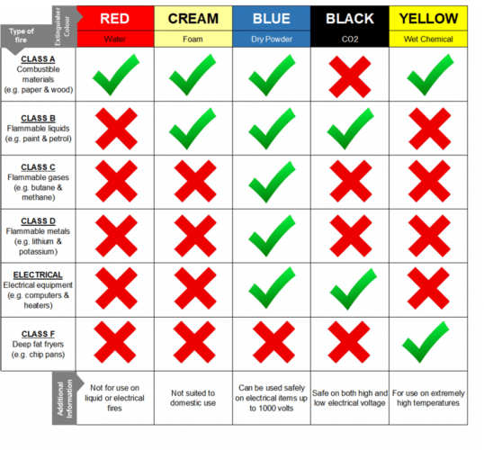

1. Class A, B and Electrical have multiple options for extinguishing those kinds of fires. **For each one, is there a “best” option?** Why or why not?

|  |
| --- |
|  |

1. **In our warehouse fire situation, what do we think is the most likely cause of the fire?**

|  |
| --- |
|  |

1. **What type of extinguishing method *should* our solution use and why?**

|  |
| --- |
|  |

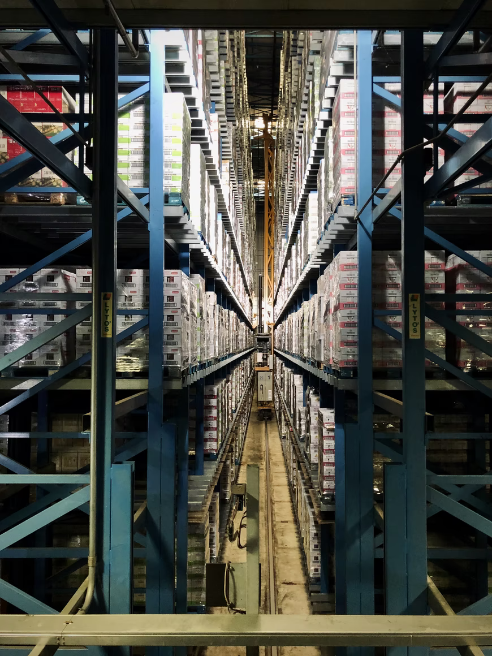 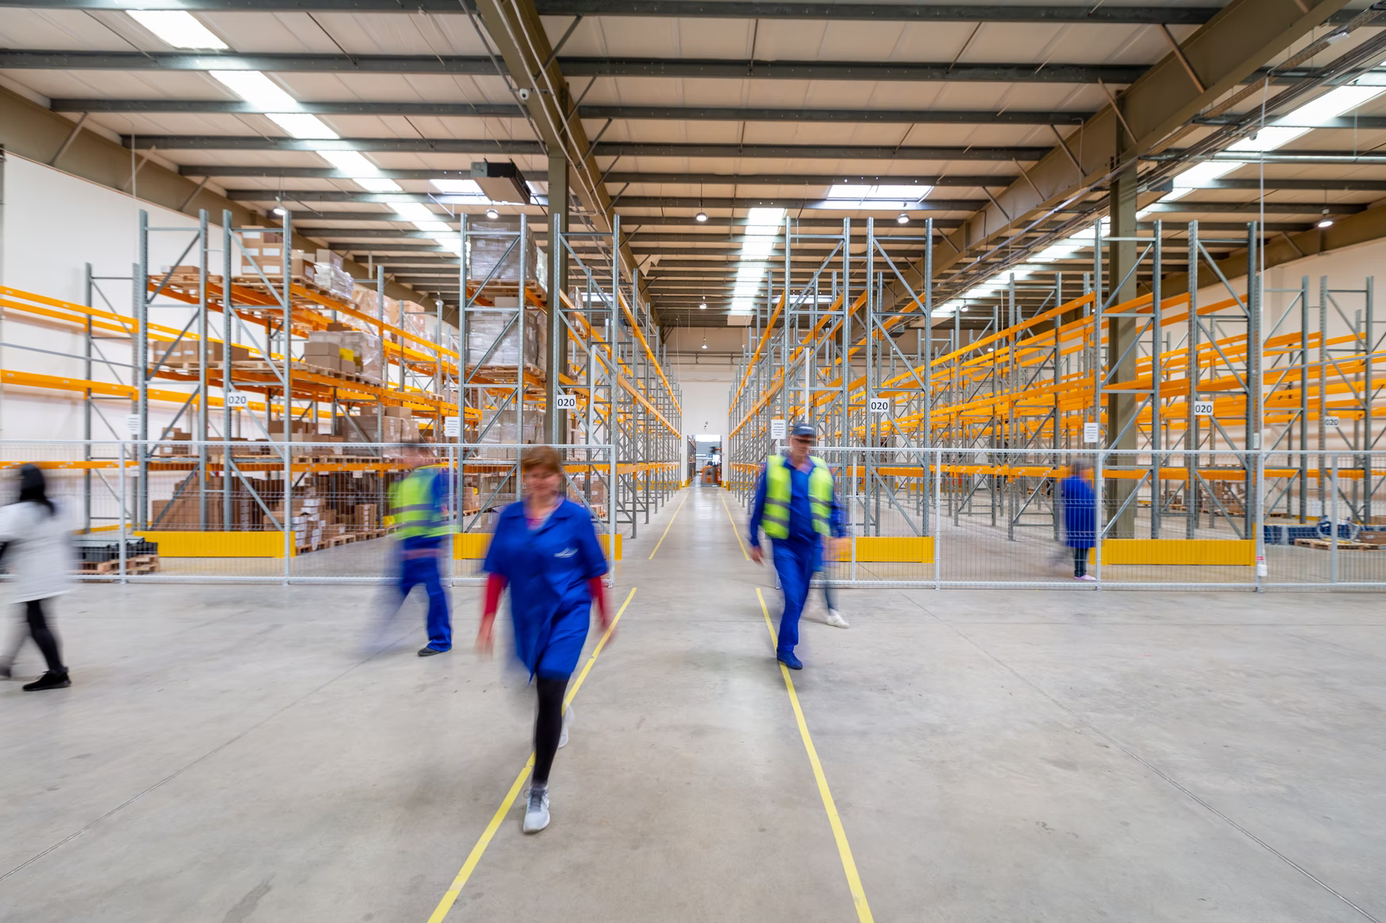

You can now return to the platform and navigate to the Research step in the fourth subsystem: <https://app.createbase.co.nz/project/heat-seeker/create/Extinguishing%20fires/research>

If you are going to create your solution using **Flow**, then read the Flow: While Loops and Flow: Fire Blocks documents. If you are going to create your solution using **JavaScript**, then read the JS: Advanced Control and JS: Sensing Functions documents instead.

Make sure that you understand the content as you will need it to plan and create your solution! When you have read the appropriate documents for the language you will be using, return to this document and answer the following questions:

1. List the sensing blocks or functions that your robot will need to use to follow a line.

|  |
| --- |
|  |

1. For each of these blocks or functions, what do they measure?

|  |
| --- |
|  |

1. For each of these blocks or functions, what type of sensor would be required to get this information?

|  |
| --- |
|  |

1. List the action blocks or functions that your robot will need to use to follow a line.

|  |
| --- |
|  |

1. For each of these blocks or functions, what action do they make our robot do? If the block or function has an input, how does this input change the resulting action?

|  |
| --- |
|  |

1. What actuators would be required to perform this action?

|  |
| --- |
|  |

### Plan

Within this step, our aim is to create a plan for how our robot could put out fires using the water hose. We have a limited supply, so we only want to use it when we need to. To do this, let’s attempt to try and answer the following questions.

1. For each of the following situations, what value would the fire sensor be showing? Choose between 0, 0.25 and 0.75
   1. Fire is close

|  |
| --- |
| Fire Sensor value: |

* 1. Fire is far but detected

|  |
| --- |
| Fire Sensor value: |

* 1. Fire is not detected

|  |
| --- |
| Fire Sensor value: |

1. Describe using a series of action words, what your robot should do in each of the following situations. In this sub-problem, the fires that we need to put out are going to be in a straight line in front of the robot.
   1. A Fire is in front of the robot:

|  |
| --- |
|  |

* 1. A fire is not in front of the robot:

|  |
| --- |
|  |

### Code

You can now return to the platform and create your answer using the simulation inside the Code step. Make sure that you refer back to the Research and Plan content in your learning journal or the platform whenever you get stuck!

When you have finished creating your answer, add a screenshot of your final solution below showing the success screen as well as either the Flow or text code. Then, write a brief explanation of how it works, including any problems that you encountered along the way and how you overcame them.

Importan**t**: *you can save your Flow code using the save icon () in the toolbar in the bottom left corner of the Flow editor. If you save your code before you leave the simulation, you will be able to continue where you left off when you return by pressing the restore icon directly below the save icon.*

*You can save your JavaScript code using the* SAVE *button in the bottom right corner of the text editor. If you save your code before you leave the simulation, you will be able to continue where you left off when you return by pressing the* RESTORE *button.*

|  |
| --- |
|  |

You can now move on to the final subsystem in Create.

# 

## Subsystem V: Putting it all together

### Research

There is nothing new to research for this subsystem. You will simply be putting together everything that you have learnt so far to build a solution for the complete problem.

### Plan

In this step, we will combine all of the logic and solutions that we have built so far to solve the full problem: navigating around the entire warehouse and putting out any fires in our way.

1. From the previous steps, there were a few conditions that you had within the code. These are what the inputs within your IF blocks within the previous steps represent. Could you list these below? You should have at least two conditions.

|  |
| --- |
|  |

1. Our objective is to follow the line and put out any fires that we encounter. According to this objective, which of the conditions you mentioned above should you verify first in your code?

|  |
| --- |
|  |

### Code

You can now return to the platform and create your answer using the simulation inside the Code step. Make sure that you refer back to the Research and Plan content in your learning journal or the platform whenever you get stuck!

When you have finished creating your answer, add a screenshot of your final solution below showing the success screen as well as either the Flow or text code. Then, write a brief explanation of how it works, including any problems that you encountered along the way and how you overcame them.

Importan**t**: *you can save your Flow code using the save icon () in the toolbar in the bottom left corner of the Flow editor. If you save your code before you leave the simulation, you will be able to continue where you left off when you return by pressing the restore icon directly below the save icon.*

*You can save your JavaScript code using the* SAVE *button in the bottom right corner of the text editor. If you save your code before you leave the simulation, you will be able to continue where you left off when you return by pressing the* RESTORE *button.*

|  |
| --- |
|  |

Congrats on building your solution! You can now move on to the Improve step to try and improve the performance of your code:

<http://app.createbase.co.nz/project/heat-seeker/improve>

# 

# Step 4: Improve

Add a screenshot of your Improve solution below and a brief explanation of how you managed to get a better performance:

|  |
| --- |
|  |

# 

# Step 5: Review

Congratulations on completing the Project! Please type your answers to the following questions:

1. If you had more time available, how could you potentially improve your solution? If your solution to the Create step didn’t work, try and explain why.

|  |
| --- |
|  |

1. Think about what you achieved during the project. What are you most proud of?

|  |
| --- |
|  |

1. Think about the parts of the project that didn’t go well. List up to **three** of them below. If nothing went bad, think about things that you could have done better.

|  |
| --- |
|  |

1. Choose **one** from question 3. Why do you think it didn’t go well? If you were going to redo this Project, what would you do differently to avoid this negative?

|  |
| --- |
|  |

1. After completing this Project, do you think that using line following robots to put out fires is feasible in real life? Why or why not?

|  |
| --- |
|  |

1. Do you think that the future of firefighting will involve the use of more robotics? Explain why or why not by providing examples of situations where robots will or won’t be useful.

|  |
| --- |
|  |